Product Rating System using Deep Learning

Aravind S

Nandha Kumar M

Rahmathullah S

Department of BTech IT

Sri Ramakrishna Institute of Technology,

Coimbatore-641010.

***Abstract*— In the age of internet shopping, customers rely significantly on product ratings and reviews to make informed purchasing decisions. As the volume of user-generated content increases, standard rating systems struggle to capture the temporal dynamics and interdependence inherent in sequential data such as product reviews. This study offers a revolutionary Product Rating System based on the Long Short-Term Memory (LSTM) algorithm, a form of recurrent neural network (RNN) developed to model sequential patterns.**

**The suggested approach seeks to improve the accuracy and effectiveness of product ratings by taking into account the temporal context of user reviews. LSTM networks are ideal for this purpose because they can capture long-range dependencies in sequential data, allowing the model to detect complex sentiments and changing opinions over time.**

**The Product Rating System's major components include data preprocessing, feature extraction, and LSTM-based sentiment analysis. Raw user reviews are preprocessed to include text normalization, tokenization, and sentiment tagging. Feature extraction entails converting preprocessed text into numerical vectors that capture the semantic and temporal characteristics of the reviews. The LSTM model is then trained on these characteristics to determine the temporal dynamics and dependencies in the data.**

**The suggested system is evaluated by comparing its performance to traditional rating systems and other cutting-edge sentiment analysis approaches. Metrics such as accuracy, precision, recall, and F1 score will be used to evaluate the system's ability to anticipate correct product ratings.**

**The expected results of this research are a more robust and adaptable Product Rating System that takes into consideration the changing nature of user feelings. The LSTM-based strategy is predicted to outperform previous methods, particularly in circumstances where temporal dependencies are critical in assessing product quality. The suggested system has the potential to drastically change the e-commerce scene by giving consumers with more accurate and timely information, allowing for better purchase decisions.**

Keywords—Sentiment Analysis, Accuracy.

# **introduction**

Product rating systems have made amazing technical advances in the digital era, impacting consumers' capacity to make educated purchase decisions. Online retail platforms used crude rating and review systems in the early days of ecommerce, when the World Wide Web was still in its infancy. These systems allowed users to post text comments and provide basic star ratings. Even though they were revolutionary at the time, these early systems lacked comprehensive analytics and complex algorithms that are today required by modern product rating systems. As the internet expanded, user-generated content and social media platforms began to play an increasing role in affecting consumer behavior.

Customer feedback and experiences might be shared in internet forums and on specialized review websites. At the same time, social media platforms such as Facebook and Twitter enabled people to share product-related tales with a bigger audience, hence increasing the influence of user-generated content. Methodologically, we integrate textual analysis approaches and machine learning algorithms.

The approach comprises mostly of the following phases. First, the sentiment dictionary is utilized to extract sentiment features, which are then employed by the Support Vector Machines algorithm to identify sentiment polarity in review texts. Sentiment themes are then retrieved from reviews with different sentiment polarity using the Latent Dirichlet Allocation (LDA) model.

Our method's key contribution is to take full use of the sentiment dictionary's sensitivity to emotional information as well as the powerful generalization of machine learning methods. Importantly, the technique overcomes the drawbacks of machine learning-based feature extraction's vulnerability to human intervention and dictionary-based methods' poor flexibility in cross-domain application. Meanwhile, the lexicon is being expanded based on semantic similarities to avoid the removal of emotional content.

Aside from that, the current study adequately accounts for the fact that words in evaluations have differential sentiment contributions, which has been overlooked in previous studies. The weighting approach is introduced throughout the sentiment feature extraction process, and it is used to quantify sentiment contribution.

Because of the growing volume of user-generated material, internet review aggregators and consumer feedback analytics tools emerged in the mid-2000s. These platforms aggregated and analyzed evaluations from a variety of sources in an attempt to simplify the flood of information. Using data analytics, they were able to uncover trends in customer sentiment and harvest useful information from reviews, allowing consumers to evaluate the overall quality of goods and services.

When machine learning and advanced data analytics were combined in the late 2000s and early 2010s, product rating systems saw a significant revolution. Machine learning algorithms were developed to assess the relevance of reviews to specific items, examine the emotional tone of reviews using sentiment analysis, and identify the truthfulness of reviewers.

## **Problem Statement**

Product rating systems have become indispensable tools for customers seeking reliable assistance when making purchases in the rapidly expanding digital marketplace. However, a number of major difficulties jeopardize the effectiveness of these systems. First, the frequency of faked and manipulated reviews weakens customer confidence by calling into question the ratings' veracity.

Second, customers may find it difficult to draw significant conclusions from product evaluations since there are no standardized review standards and an abundance of unstructured user-generated information.

Third, there may be disparities between user expectations and product performance since product rating systems usually fail to account for changing customer demands and preferences.

These concerns must be rectified in order to ensure that product rating systems continue to provide customers with valuable, trustworthy, and relevant information—and, as a result, improve their online shopping experience.

1. ***Application of Product Rating System:***

Deep learning-enhanced product rating systems offer a wide range of applications across businesses and areas. Here are a few prominent applications:

* ***E-commerce and Retail:***

Deep learning-powered product rating systems are widely utilized in e-commerce platforms such as Amazon, Walmart, and eBay to assess customer feedback and ratings. These systems can automatically detect fraudulent reviews, measure product sentiment, and give more accurate aggregate ratings, allowing customers to make more educated purchase decisions.

* ***Restaurant and Food Services:***

Apps such as Yelp and Zomato utilize deep learning to evaluate user reviews and ratings for restaurants and food services. This technology supports sentiment analysis, which extracts useful information from customer input to enhance restaurant suggestions and evaluations.

* ***Movie and Entertainment Industry****:*

Deep learning is used by platforms such as Rotten Tomatoes and IMDb to assess user and critic evaluations of films, television shows, and video games. This assists in compiling review scores and offering more accurate suggestions to viewers and players.

* ***Hospitality and Travel:***

Travel websites such as TripAdvisor leverage deep learning to analyze user reviews for hotels, vacation rentals, and travel destinations. These systems help in ranking accommodations and destinations based on user sentiments and preferences.

* ***Healthcare and Medical Products:***

Deep learning-powered product rating systems are being used to assess and categorize user input on healthcare items, medications, and medical services. These technologies enable people and healthcare providers to make educated decisions about medical treatments and goods.

* ***Automotive Industry:***

Deep learning is used by automotive websites such as Edmunds and Kelley Blue Book to examine user evaluations and ratings of automobiles and vehicles. This information is helpful to potential purchasers in their decision-making process.

* ***Consumer Electronics*:**

Deep learning-based product rating systems are commonly used for evaluating smartphones, laptops, and other consumer goods. Consumers may utilize these systems to analyze product quality, durability, and performance based on user input.

* ***Real Estate and Housing:***

Real estate platforms utilize deep learning to assess user evaluations and ratings of real estate agents, property listings, and rental services. This technology helps potential tenants and purchasers make housing-related decisions.

* ***Educational Resources:***

Deep learning-based rating systems are used by online educational platforms to review and rate courses, textbooks, and other educational resources. These systems provide students and instructors with useful information on the quality and efficacy of educational materials.

* ***Travel Booking and Tourism:***

Deep learning is used by travel booking websites to examine user ratings of travel experiences such as tours, excursions, and travel packages. This technology helps to recommend and rate travel possibilities.

## **Related Works**

The rapid growth of the product rating system can be linked to advancements in digital technology and the internet. E-commerce was in its infancy during the early days of the World Wide Web. Customers could now rate things and post text reviews when online merchants such as Amazon and eBay introduced basic rating and review systems in the late 1990s and early 2000s.

These early systems were quite simplistic in comparison to the complicated algorithms and analytics that we see today. The next significant technical advancement was the proliferation of social media and user-generated content platforms. Customers may share their experiences and thoughts about various items on websites and forums dedicated to product evaluation and debate. As user-generated material increased, these platforms became valuable informative tools for prospective clients. Social media platforms such as Facebook and Twitter amplify the influence of user-generated content.

Product rating systems have evolved since the late 2000s and early 2010s, with the development of machine learning, deep learning, and advanced data analytics. Algorithms were designed to assess reviewer dependability, analyze sentiment, and establish the relevance of a review to a certain product. This increased the accuracy and dependability of ratings and reviews. To address integrity problems, machine learning was employed to automatically detect bogus reviews and review manipulation.

Product rating systems, which incorporate a number of technology components, are an important part of the current e-commerce scene. These include machine learning models that can assess reviewer dependability and automatically filter out irrelevant or fraudulent content; natural language processing (NLP) for sentiment analysis; and data mining for extracting valuable information from reviews. Systems for controlling reputation and trust have also been implemented to ensure the integrity of review sites.

## **Existing System**

Our project's current system is powered by Support Vector Machines (SVM) and Latent Dirichlet Allocation (LDA). Topics and themes are extracted from textual user evaluations using a topic modeling approach known as Latent Domain Analysis (LDA). It provides a rigorous framework for interpreting the underlying trends in reviews, allowing you to identify repeating themes that may influence product evaluations. SVMs are used in two applications: rating prediction and sentiment analysis. Strong machine learning models such as support vector machines excel in determining whether language is positive, negative, or neutral.

**5.1. *Limitations of the existing system:***

* ***Lack of Review Credibility Assessment:***

There are no processes in place to assess reviewer credibility, the system is vulnerable to false reviews and manipulation.

* ***Time Sensitivity:***

It's probable that the system won't account for changes in user mood over time. The system may not be able to record changes in sentiment over time as product experiences change, which might be critical for dynamic commodities or services.

* ***Limited Review Relevance:***

The present system's failure to appropriately filter out irrelevant or off-topic reviews may have an influence on the accuracy of sentiment analysis and rating forecasts.

* ***Handling Multimodal Data Can Be Difficult:***

Because it only employs textual data, it is unable to include other forms of user-generated information such as photographs, videos, and audio, which can provide valuable context and sentiment signals.

* ***Scalability:***

When dealing with big review numbers, the present system's performance may decrease, making it more difficult to provide timely insights for items with a large amount of user comments.

* ***Difficult Model Tuning:***

SVM model fine-tuning can be challenging and time-consuming, necessitating a significant amount of effort to improve model parameters for exact sentiment analysis.

## **Scope of the project**

The "Product Rating System Using Deep Learning" project has the potential to develop into a cutting-edge and incredibly helpful application. The purpose of this system is to apply deep learning to address the inadequacies of existing product rating systems. This project's scope includes data gathering, preprocessing, model construction, and application across many domains. The scope's major focus is on collecting a diverse dataset of product evaluations and ratings from a variety of sources, including restaurant review systems and e-commerce websites. Data preparation is an important stage since it involves cleaning, organizing, and converting unstructured text data into a format suitable for deep learning using methods such as natural language processing (NLP). The primary goal of the research is to develop deep learning models. This includes creating neural networks, perhaps using transformer-based models like BERT or neural network topologies such as recurrent neural networks (RNNs). These models will be trained to address basic issues with product rating systems, such as sentiment analysis, review relevance evaluation, and credibility assessment. The project's scope also includes the development of an intuitive user interface that allows users to access and interact with the upgraded ratings system. The interface will include features such as product comparisons, review summaries, and aggregated ratings. These features will be powered by the deep learning model, ensuring a seamless and informative experience.

# ***Working of the proposed system***

The proposed method enhances the analysis of user-generated material, such as product evaluations, by incorporating Long Short-Term Memory (LSTM) algorithms into the product rating system. The LSTM is a type of recurrent neural network (RNN) that excels at processing textual information that varies over time due to its ability to perceive and comprehend sequential relationships in data. Regarding the product rating system, LSTM operates as follows:

A series of phrases or tokens from a product review are first consumed by LSTM, which considers their presence in context and order. This allows LSTM to recognize both the underlying temporal patterns in language and the evolution of thoughts or emotions throughout the course of a review. In contrast to traditional sentiment analysis algorithms, which treat text as a collection of words, LSTM acknowledges that word order is important since context may influence how a statement is received.

As the review progresses, LSTM creates a hidden state for each word encountered. By mixing input from previous words with the present word, this dynamic hidden state enables the model to recall what it has previously seen. Understanding complex phrase constructions and subtle idioms common in product evaluations is strongly reliant on this memory function.

The LSTM model learns the associations between words and sentiments over time by training on a huge dataset of product evaluations with predefined sentiment labels. During training, the model updates its internal parameters to increase its ability to predict sentiment from the reviews it reads.

Once trained, the LSTM model can assess new, unread product reviews. It evaluates the text's tone and emotional signals by examining the word order and contextual information. As a result, sentiment analysis becomes more exact and context-aware, allowing the system to provide a more in-depth knowledge of user preferences and opinions.

The emotion and rating scores from numerous reviews are then merged by the LSTM enhanced product rating system to offer a comprehensive evaluation of a product's quality and consumer satisfaction. Using LSTM, the system dives into language intricacies and goes beyond basic sentiment analysis, improving the precision and range of information it provides to consumers, businesses, and online platforms. As a result, the whole user experience is improved, allowing for more informed decision-making in the digital marketplace.

## **Sentiment Analysis**

Sentiment analysis, a powerful natural language processing technology with high relevance in the online marketplace, is an integral component of the product rating system. It enables the system to assess qualitative components of user-generated information, particularly product reviews, in addition to traditional quantitative evaluations. This approach provides valuable insights into how consumers perceive and use goods and services by thoroughly analyzing the emotions, sentiments, and opinions conveyed in text data.

Sentiment analysis is the technique of determining whether text expresses neutral, positive, or negative attitude. Modern sentiment analysis algorithms, on the other hand, are much more complex, capable of identifying emotions, capturing subtle sentiment expressions, and providing richer context analysis.

A product rating system requires this level of analysis to provide users with a more complete and detailed picture of the product's performance, quality, and satisfaction.

Machine learning algorithms and a variety of natural language processing techniques are used in sentiment analysis. These methods analyze reviews, extract pertinent data, and evaluate the text's emotional content. The ability to recognize words that convey emotion, comprehend sentence structures, and analyze context to discern irony, sarcasm, or conflicting emotions are important components. The sentiment analysis process is more accurate and reliable overall thanks to this multifaceted approach.

Sentiment analysis is very helpful to the product rating system because it makes it possible to extract insights from user reviews at a scale that would be difficult to accomplish manually. It improves the system's capacity to spot patterns, pinpoint typical problems, and pinpoint areas where particular products shine. Furthermore, sentiment analysis supports transparency and trust in the digital marketplace by assisting the system in addressing issues such as manipulated and fraudulent reviews.

Sentiment analysis is essentially the foundation of the product rating system; it helps consumers make better decisions and provides businesses and online platforms with insightful data about customer feedback. The product rating system is elevated by the fusion of cutting-edge sentiment analysis methods with cutting-edge technologies, like deep learning with LSTM. This gives businesses a competitive edge in the constantly changing digital landscape and offers users a sophisticated and reliable resource.

## **Long-Short Term Model**

The Long Short-Term Memory (LSTM) algorithm plays an important role in the product rating system, providing a sophisticated and nuanced method for assessing user-generated material, notably product reviews. Unlike classic sentiment analysis algorithms, LSTM excels at comprehending temporal relationships in language, making it ideal for capturing shifting sentiments stated in reviews.

In practice, LSTM begins by scanning through a product review's content and parsing each word, taking into consideration its position in the text and context. This critical difference acknowledges that words in a phrase are not isolated but rather interrelated, with context and order having a substantial influence on meaning. Because of its capacity to process language sequentially, LSTM can understand the complex sentence patterns and subtle phrases seen in product evaluations.

While LSTM examines the review, it maintains track of previously encountered words and blends them with the term it is now utilizing to produce a developing hidden state. This dynamic hidden state represents the model's memory, allowing it to recall context throughout the review process.

This memory function is very useful when dealing with user-generated content, which varies substantially in length and complexity. It is critical to understand the progression of ideas and emotions in a review.

After training, the LSTM model may analyze new, unpublished product reviews. It evaluates word order by considering each word's context and its link to the overall mood represented in the review. This results in a more accurate, context-aware sentiment analysis that goes beyond simple positive/negative categorization, allowing the system to provide a better understanding of user preferences and opinions.

LSTM enhances the whole sentiment analysis process for the product rating system, allowing it to more efficiently assemble and evaluate sentiment and rating scores from a large number of reviews. This results in a more comprehensive and perceptive assessment of a product's quality and client satisfaction.

The product rating system uses LSTM to go beyond simple sentiment analysis, examining linguistic subtleties and increasing the breadth and precision of the data it provides to customers, businesses, and online platforms. Finally, this enhances the user experience and allows for more informed decisions in the online market.

## **Result**

* 1. ***Output of the proposed system:*** 
     1. ***Previewing dataset:***

The output of the algorithm that has been trained using valid dataset. The dataset can be viewed as

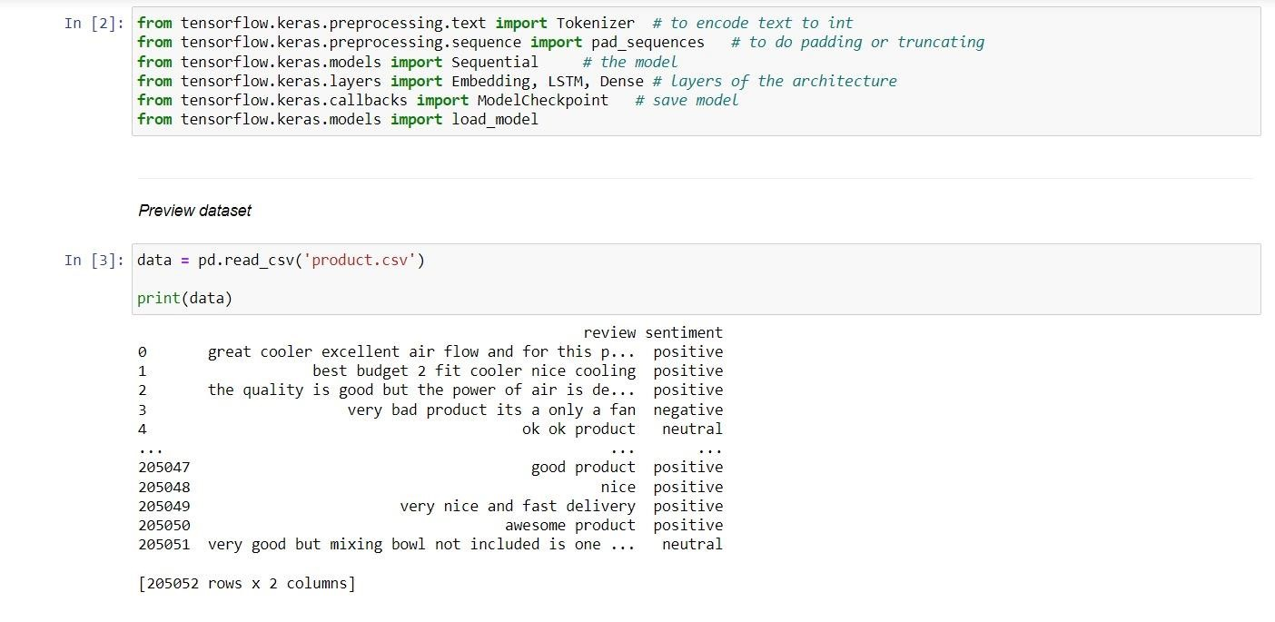

Previewing Dataset

* + 1. ***Splitting Dataset:***

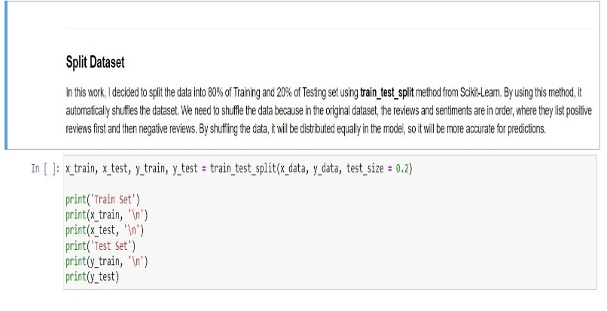The dataset has been splitted into 80-20 so that the 80% of the dataset can be used to train the algorithm and the remaining 20% is for the testing process.

Splitting dataset

* + 1. ***Training the Model:***

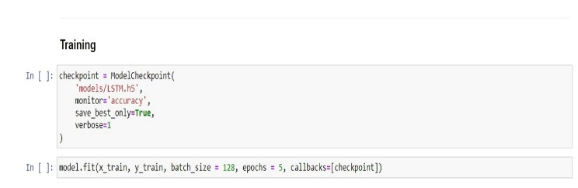Now the model is being trained using the dataset to attain certain accuracy

Training the model

* + 1. ***Accuracy:***

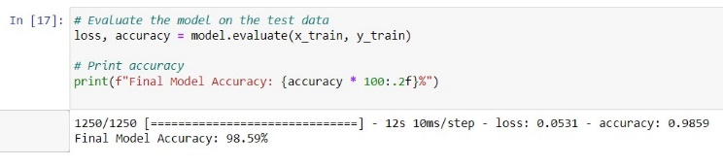After training the model, the final accuracy obtained from the model is 98.59%

Accuracy of the Model

* 1. ***Web Application:***

The web application has been created by using Streamlit, a platform used to develop web application like Django and Flask. It runs through python and it is significantly faster than Django and Flask.

* + 1. 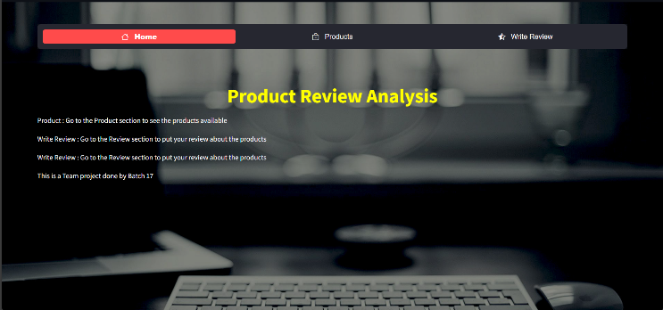***Home Page:***

Homepage for the Product Rating System

* + 1. ***Review page:***

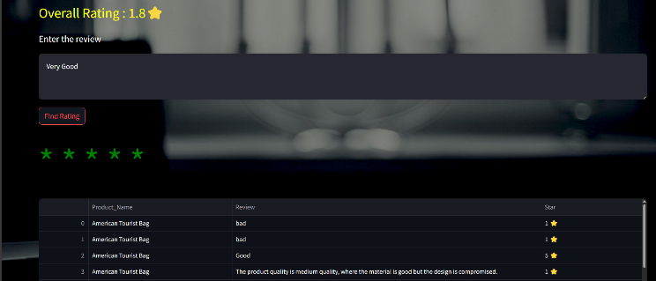

Reviewing page for the products

## **Conclusion**

In summary, the product rating system is an important aspect of the online marketplace that serves both businesses and consumers. Its capabilities have evolved over time to include complex approaches such as sentiment analysis and, more recently, deep learning models such as LSTM.

The product rating system provides clients with reliable information to assist them make informed purchase decisions. It improves the purchasing experience by giving detailed information on product quality and consumer happiness.

The technology provides companies with real-time client input, which aids in strategy, product development, and marketing efforts. Furthermore, by prohibiting review manipulation, it increases openness and confidence.

Sentiment analysis takes on additional dimensions with the use of deep learning, particularly LSTM, which aids in the resolution of adaptation challenges and linguistic complications. This invention has the potential to totally revolutionize the system by giving more accurate and context-relevant reviews and ratings.

To meet the ever-changing digital world, the product rating system will most likely continue to evolve. It will remain a crucial instrument for increasing trust, transparency, and well-informed decision-making in the online economy by leveraging cutting-edge technology and data-driven insights.

##### ***References***

[1]. Y. Xiong, S. Chen, H. Qin, H. Cao, Y. Shen, X. Wang, Q. Chen, J. Yan, and B. Tang, ‘‘Distributed representation and one-hot representation fusion with gated network for clinical semantic textual similarity,’’ BMC Med. Informat. Decis. Making, vol. 20, no. S1, pp. 1–7, Apr.

2020.

[2]. C. Campbell and J. R. Farrell, ‘‘More than meets the eye: The functional components underlying influencer marketing,’’ Bus. Horizons, vol. 63, no. 4, pp. 469–479, Jul. 2020.

[3]. K. Thirumaran, H. Jang, Z. Pourabedin, and J. Wood, ‘‘The role of social media in the luxury tourism business: A research review and trajectory assessment,’’ Sustainability, vol. 13, no. 3, pp. 12–16, 2021.

[4]. U. Warrier, P. Singh, and C. W. Jien, ‘‘Factors that lead Amazon.com to a successful online shopping platform,’’ Int. J. Tour. Hosp. Asia Pasific, vol. 4, no. 1, pp. 7–17, 2021.

[5]. J. Liu, S. Zheng, G. Xu, and M. Lin, ‘‘Cross-domain sentiment aware word embeddings for review sentiment analysis,’’ Int. J. Mach. Learn. Cybern., vol. 12, no. 2, pp. 343–354, Feb.

2021.

[6]. M. Tanveer, T. Rajani, R. Rastogi, Y. H. Shao, and M. A. Ganaie, ‘‘Comprehensive review on twin support vector machines,’’ Ann. Oper. Res., pp. 1–46, Mar. 2022,

[7]. J. R. Saura, D. Ribeiro-Soriano, and P. Z. Saldaña, ‘‘Exploring the challenges of remote work on Twitter users’ sentiments: From digital technology development to a post-pandemic era,’’ J. Bus. Res., vol. 142, pp. 242–254, Mar. 2022.

[8]. X. Wang, T. Lv, and L. Fan, ‘‘New energy vehicle consumer demand mining research based on fusion topic model: A case in China,’’ Sustainability, vol. 14, no. 6, p. 3316, Mar.

2022.

[9]. P. Dash, J. Mishra, and S. Dara, ‘‘Sentiment analysis on social network data and its marketing strategies: A review,’’ ECS Trans., vol. 107, no. 1, pp. 7417–7425, Apr. 2022.

[10]. Y. Xiong, S. Chen, H. Qin, H. Cao, Y. Shen, X. Wang, Q. Chen, J. Yan, and B. Tang, ‘‘Distributed representation and one-hot representation fusion with gated network for clinical semantic textual similarity,’’ BMC Med. Informat. Decis. Making, vol. 20, no. S1, pp. 1–7, Apr.

2020.

[11]. V. Chang, L. Liu, Q. Xu, T. Li, and C. Hsu, ‘‘An improved model for sentiment analysis on luxury hotel review,’’ Expert Syst., Jun. 2020..